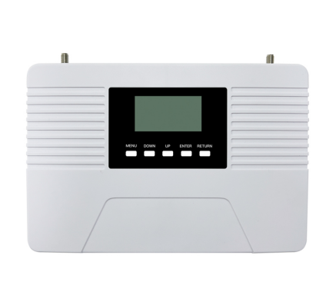
1800+2100+2600MHz Wid band Repeater
Model: NB-DWL

Product Features:
- Improve mobile voice&networks at the same time
- LCD display the input/output signal strength
- Auto isolation detect function
- Auto gain control ,auto level control
- Auto uplink noise reduction,avoid disturbing to BTS
- Smart LCD to guide the installation

Working Schematic Diagram
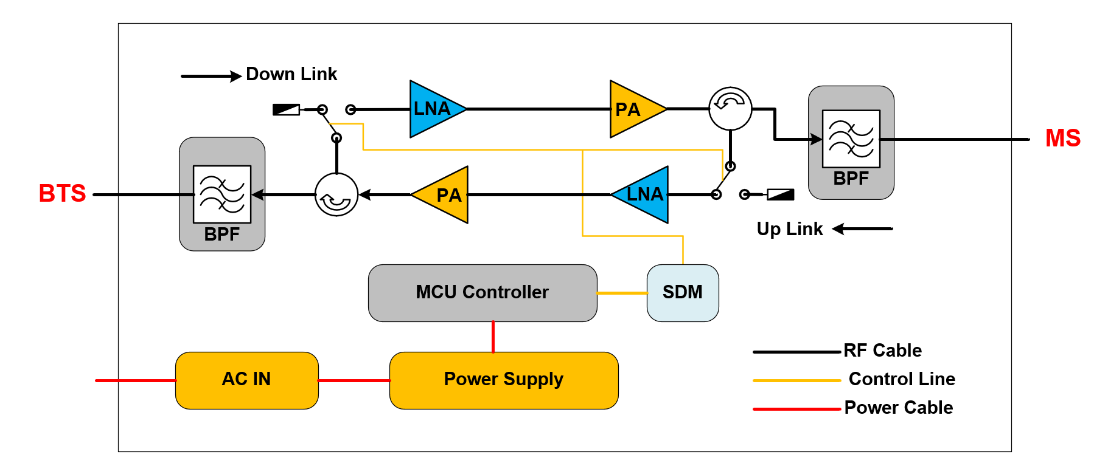Application Scenario:
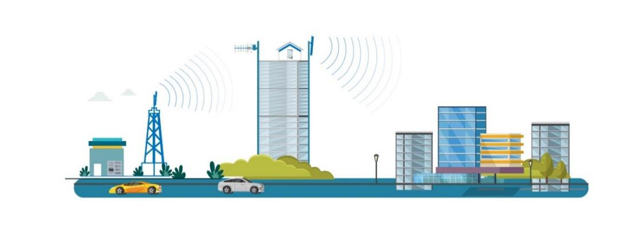

Technical Specifications:
P/N: NB-DWL |  | B7 (2600MHz) |  | B3 (1800MHz) | B1 (2100MHz)
Frequency Range | Uplink | 2500-2570MHz |  | 1710-1785MHz | 1920-1980MHz
Frequency Range | Downlink | 2620-2690MHz |  | 1805-1880MHz | 2110-2170MHz
Bandwidth |  | 70MHz |  | 75MHz | 60MHz
Max. Gain | Uplink | 65±3 dB |  | 65±3 dB | 65±3 dB
Max. Gain | Downlink | 70±3 dB |  | ≧ 70±3 dB | 70±3 dB
Manual Gain Control |  | 31 dB in step of 1 dB
Automatic Gain Control |  | ≧ 20 dB
Gain Flatness (per sub-band) |  | ≦ ±3 dB (peak-to-peak)
Max. Input Power Without Damage |  | 0 dBm
Output Power | Uplink | 17±2 dBm | 17±2 dBm |  | 17±2 dBm
Output Power | Downlink | 20±2 dBm | 20±2 dBm |  | ≧ 20±2 dBm
Spurious Emission | 9KHz-1GHz | ≦ -36dBm
Spurious Emission | 1GHz-12.75GHz | ≦ -30dBm
ACRR | ±20/100MHz | ≦-36dBc/30KHz
ACRR | ±40/200MHz | ≦-40dBc/30KHz
EVM |  | ≦ 8 %
Frequency Stability |  | ≦ ±0.01 ppm
Noise Figure |  | ≦ 9dB
VSWR |  | ≦ 2.5
System Delay |  | ≦ 6 µs
RF Connector |  | N-Female
Impedance |  | 50 Ω
Power Supply |  | AC 100/ 240 V
Power Consumption |  | ≦ 15 W
Dimensions |  | 205×170×38mm
Weight |  | ≦ 2.5 kgs
IP Rating |  | IP40
Operating Temperature |  | -25 °C to 55 °C
Control & Monitoring | Local | WIFI(Optional)
Technical specification is subject to change without prior notice.

